Libya

## GNI per capita and development level

The data set shows the GNI per capita and development level of the country each year.

## # A tibble: 19 x 5  
## country iso3c date GNIperCapita devCategory   
## <chr> <chr> <dbl> <dbl> <chr>   
## 1 Libya LBY 1996 2321. Upper Middle Income  
## 2 Libya LBY 1998 3636. Lower Middle Income  
## 3 Libya LBY 2000 2924. Lower Middle Income  
## 4 Libya LBY 2002 3994. Lower Middle Income  
## 5 Libya LBY 2003 4913. Upper Middle Income  
## 6 Libya LBY 2004 43080. High Income   
## 7 Libya LBY 2005 43080. High Income   
## 8 Libya LBY 2006 43080. High Income   
## 9 Libya LBY 2007 43080. High Income   
## 10 Libya LBY 2008 43080. High Income   
## 11 Libya LBY 2009 36417. High Income   
## 12 Libya LBY 2010 12060. Upper Middle Income  
## 13 Libya LBY 2011 35448. High Income   
## 14 Libya LBY 2012 5331. Upper Middle Income  
## 15 Libya LBY 2013 3955. Lower Middle Income  
## 16 Libya LBY 2014 4009. Lower Middle Income  
## 17 Libya LBY 2015 3313. Lower Middle Income  
## 18 Libya LBY 2016 3291. Lower Middle Income  
## 19 Libya LBY 2017 40435. High Income

## GDP growth and economic growth classification

The data set shows the GDP growth and the ecomic growth classification of the country each year.

## # A tibble: 19 x 5  
## country iso3c date GDPannualGrowthRate GDPgrowthCategory4  
## <chr> <chr> <dbl> <dbl> <fct>   
## 1 Libya LBY 1996 2.64 moderate growth   
## 2 Libya LBY 1998 3.73 moderate growth   
## 3 Libya LBY 2000 3.68 moderate growth   
## 4 Libya LBY 2002 -0.959 negative grwoth   
## 5 Libya LBY 2003 13.0 fast growth   
## 6 Libya LBY 2004 4.46 moderate growth   
## 7 Libya LBY 2005 11.9 fast growth   
## 8 Libya LBY 2006 6.50 fast growth   
## 9 Libya LBY 2007 6.35 fast growth   
## 10 Libya LBY 2008 2.67 moderate growth   
## 11 Libya LBY 2009 -0.790 negative grwoth   
## 12 Libya LBY 2010 5.02 moderate growth   
## 13 Libya LBY 2011 -62.1 negative grwoth   
## 14 Libya LBY 2012 123. fast growth   
## 15 Libya LBY 2013 -13.6 negative grwoth   
## 16 Libya LBY 2014 -24.0 negative grwoth   
## 17 Libya LBY 2015 -8.86 negative grwoth   
## 18 Libya LBY 2016 -2.80 negative grwoth   
## 19 Libya LBY 2017 26.7 fast growth

## Development trend

The plot shows the development trend of the country.

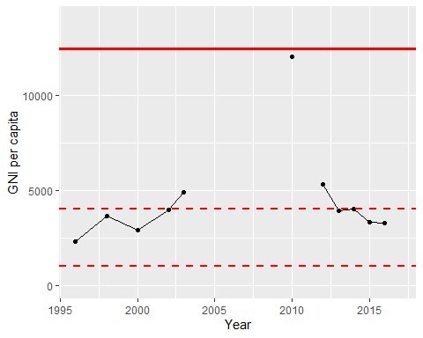

GNI Per Capita Trend